**Mission 1**

**Issue**: Due to the DoS attack, the Empire took down the Resistance's DNS and primary email servers.

* The Resistance's network team was able to build and deploy a new DNS server and mail server.
* The new primary mail server is asltx.l.google.com and the secondary should be asltx.2.google.com.
* The Resistance (starwars.com) is able to send emails but unable to receive any.

Your mission:

* Determine and document the mail servers for starwars.com using NSLOOKUP.
  + 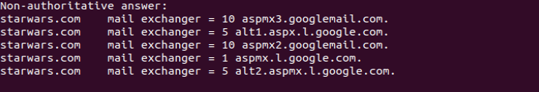
* Explain why the Resistance isn't receiving any emails.
  + No emails were received because they were being sent to spam or blocked entirely.
* Document what a corrected DNS record should be.
  + Starwars.com mail exchanger = 1 asltx.l.google.com
  + Starwars.com mail exchanger = 5 asltx.l.google.com

**Mission 2**

**Issue**: Now that you've addressed the mail servers, all emails are coming through. However, users are still reporting that they haven't received mail from the theforce.net alert bulletins.

* Many of the alert bulletins are being blocked or going into spam folders.
* This is probably due to the fact that theforce.net changed the IP address of their mail server to 45.23.176.21 while your network was down.
* These alerts are critical to identify pending attacks from the Empire.

Your mission:

* Determine and document the SPF for theforce.net using NSLOOKUP.
  + 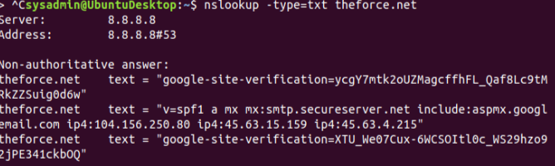
* Explain why the Force's emails are going to spam.
  + The Forces DNX record is out of date and needs to be updated. This would allow for emails to be received outside of spam or being blocked.
* Document what a corrected DNS record should be.
  + Theforce.net text = “v=spf1 a mx mx:smtp.secureserver.net include:aspmx.googleemail.com include: 45-23-178-21.lightspeed.rcsntx.sbcglobal.net ip4:104.156.250.80 ip4:45.63.15.159 ip4:45.63.4.215”

**Mission 3**

**Issue**: You have successfully resolved all email issues and the resistance can now receive alert bulletins. However, the Resistance is unable to easily read the details of alert bulletins online.

* They are supposed to be automatically redirected from their sub page of resistance.theforce.net to theforce.net.

Your mission:

* Document how a CNAME should look by viewing the CNAME of www.theforce.net using NSLOOKUP.
  + 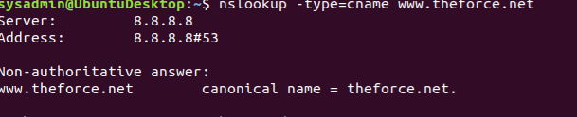
* Explain why the sub page of resistance.theforce.net isn't redirecting to theforce.net.
  + The DNS record is missing a reference from resistance.theforce.net to www.theforce.net
* Document what a corrected DNS record should be.
  + [www.theforce.net](http://www.theforce.net) canonical name – theforce.net
  + Resistance.theforce.net canonical name – [www.theforce.net](http://www.theforce.net)

**Mission 4**

**Issue**: During the attack, it was determined that the Empire also took down the primary DNS server of princessleia.site.

* Fortunately, the DNS server for princessleia.site is backed up and functioning.
* However, the Resistance was unable to access this important site during the attacks and now they need you to prevent this from happening again.
* The Resistance's networking team provided you with a backup DNS server of: ns2.galaxybackup.com.

Your mission:

* Confirm the DNS records for princessleia.site.
  + Princessleia.sire nameserver = ns25.domaincontrol.com
  + Princessleia.site nameserver = ns2.galaxybackup.com
* Document how you would fix the DNS record to prevent this issue from happening again.
  + Princessleia.site nameserver = ns25.domaincontrol.com
  + Princesslei.site nameserver = ns2.galaxybackup.com

**Mission 5**

**Issue**: The network traffic from the planet of Batuu to the planet of Jedha is very slow.

* You have been provided a network map with a list of planets connected between Batuu and Jedha.
* It has been determined that the slowness is due to the Empire attacking Planet N.

Your Mission:

* View the [Galaxy Network Map](/asu-coding-bootcamp/asu-glen-cyber-pt-11-2020-u-c/-/raw/master/09-Networking-Fundamentals-II-and-CTF-Review/Homework/resources/Galaxy_Network_map.png) and determine the OSPF shortest path from Batuu to Jedha.
* D(1) > C(2) > E(1) > F(1) > J(1) > I(1) > L(6) > Q(4) > T(2) > V(2)
* Confirm your path doesn't include Planet N in its route.D >C >E >F >J >I >L >Q >T >V
* Document this shortest path so it can be used by the Resistance to develop a static route to improve the traffic.
  + 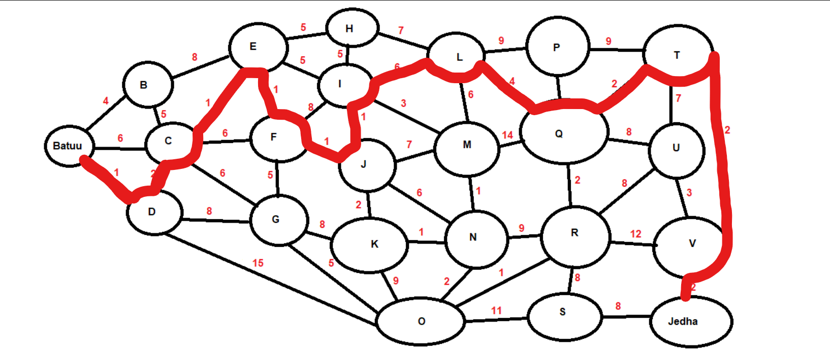

**Mission 6**

**Issue:** Due to all these attacks, the Resistance is determined to seek revenge for the damage the Empire has caused.

* You are tasked with gathering secret information from the Dark Side network servers that can be used to launch network attacks against the Empire.
* You have captured some of the Dark Side's encrypted wireless internet traffic in the following pcap: [Darkside.pcap](/asu-coding-bootcamp/asu-glen-cyber-pt-11-2020-u-c/-/blob/master/09-Networking-Fundamentals-II-and-CTF-Review/Homework/resources/Darkside.pcap).

Your Mission:

* Figure out the Dark Side's secret wireless key by using Aircrack-ng.
  + Hint: This is a more challenging encrypted wireless traffic using WPA.
  + In order to decrypt, you will need to use a wordlist (-w) such as rockyou.txt.
* Use the Dark Side's key to decrypt the wireless traffic in Wireshark.
  + Hint: The format for they key to decrypt wireless is <Wireless_key>:<SSID>.
* Once you have decrypted the traffic, figure out the following Dark Side information:
  + Host IP Addresses and MAC Addresses by looking at the decrypted ARP traffic.
  + Document these IP and MAC Addresses, as the resistance will use these IP addresses to launch a retaliatory attack.

(I have a skip a question saved from class on Monday or Wednesday and I am not sure if it applys to a whole mission or just one question in the mission. If it is not the whole mission I can come back and answer the remaining questions for this section. Thank you)

**Mission 7**

As a thank you for saving the galaxy, the Resistance wants to send you a secret message!

Your Mission:

* View the DNS record from Mission #4.
* The Resistance provided you with a hidden message in the TXT record, with several steps to follow.
* Follow the steps from the TXT record.
  + **Note**: A backup option is provided in the TXT record (as a website) in case the main telnet site is unavailable
  + 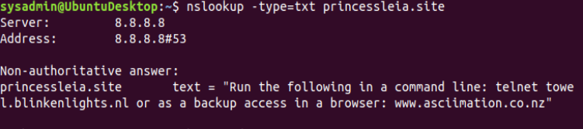
* Take a screen shot of the results.
* 